**Session 2**

**Implement AND gate with d flipflop**

**RTL/Verilog code:**

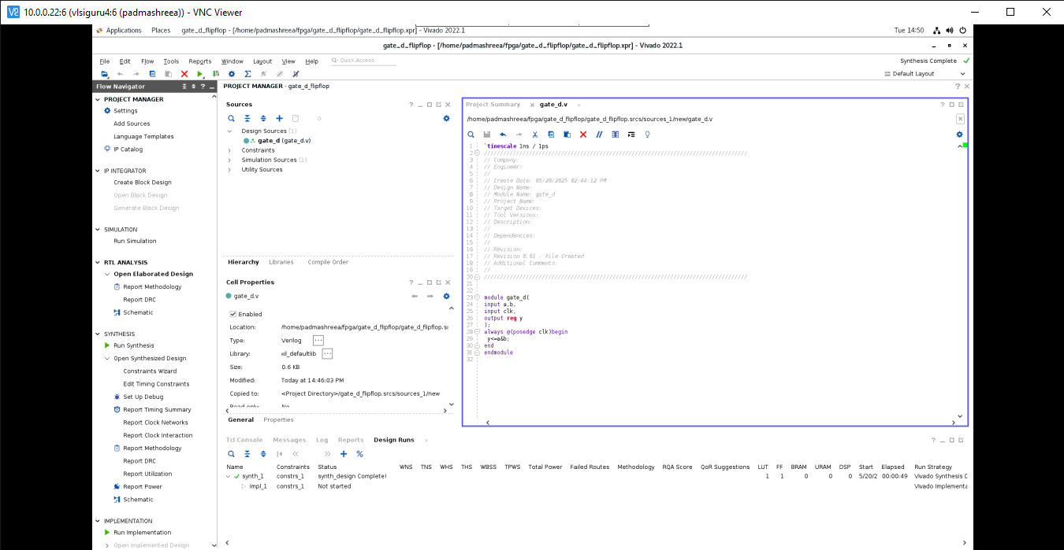

**Schematic diagram**

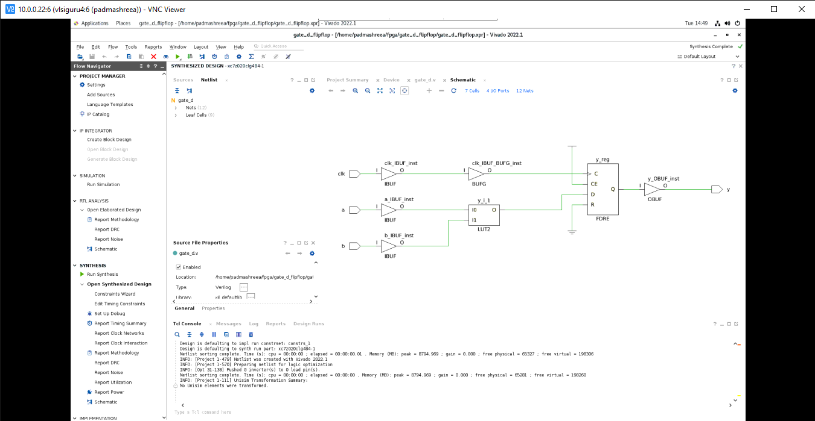

**Elaborated circuit:**

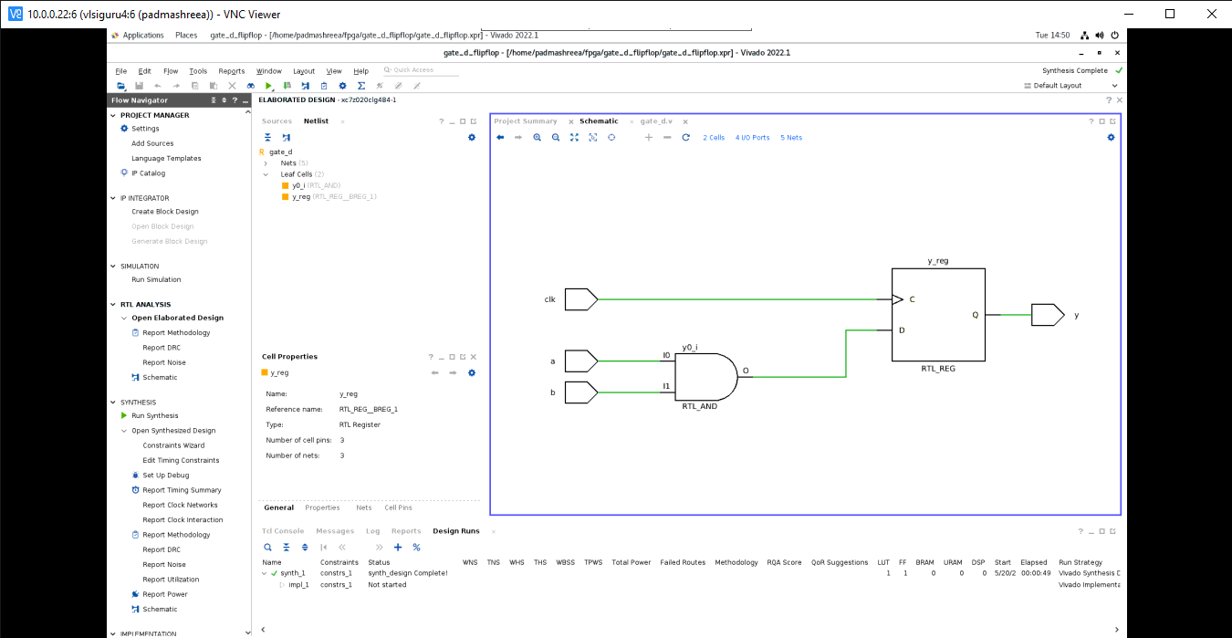

**Implement 2-bit counter using LUT and flipflop**

For counter using flip flop, first we have to draw table for present state and next state for up-counter then d flip-flop excitation table. By using excitation table of d flipflop we have to write d flip-flop outputs.

Then using k-map we have to deduce equation for D1 and D2, As follows

D1 = Q1 xor Q0

D0 = Q0’

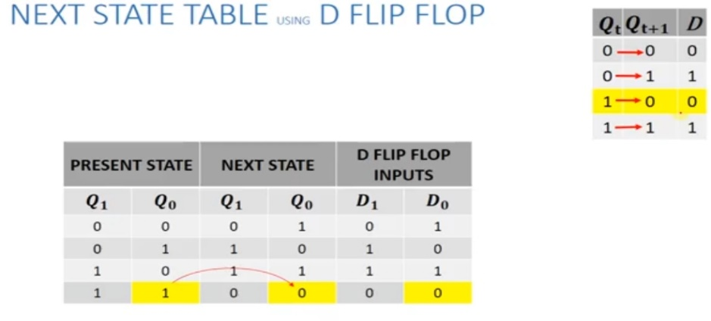

**RTL/Verilog code:**

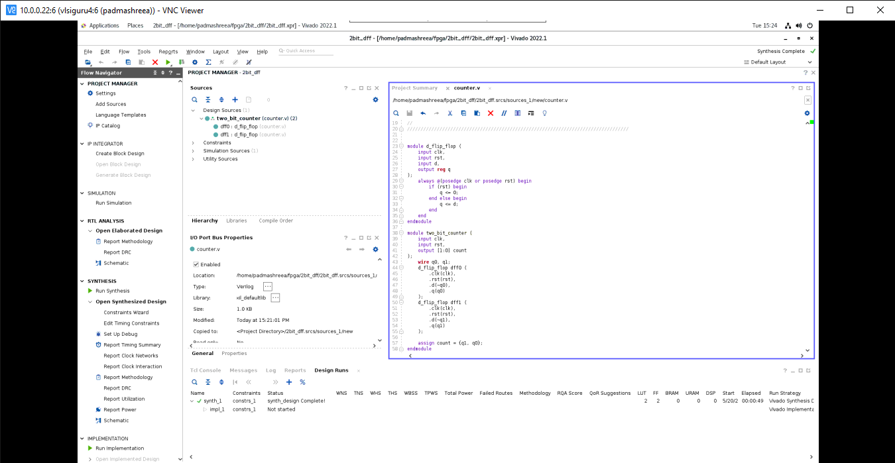

**Schematic diagram:**

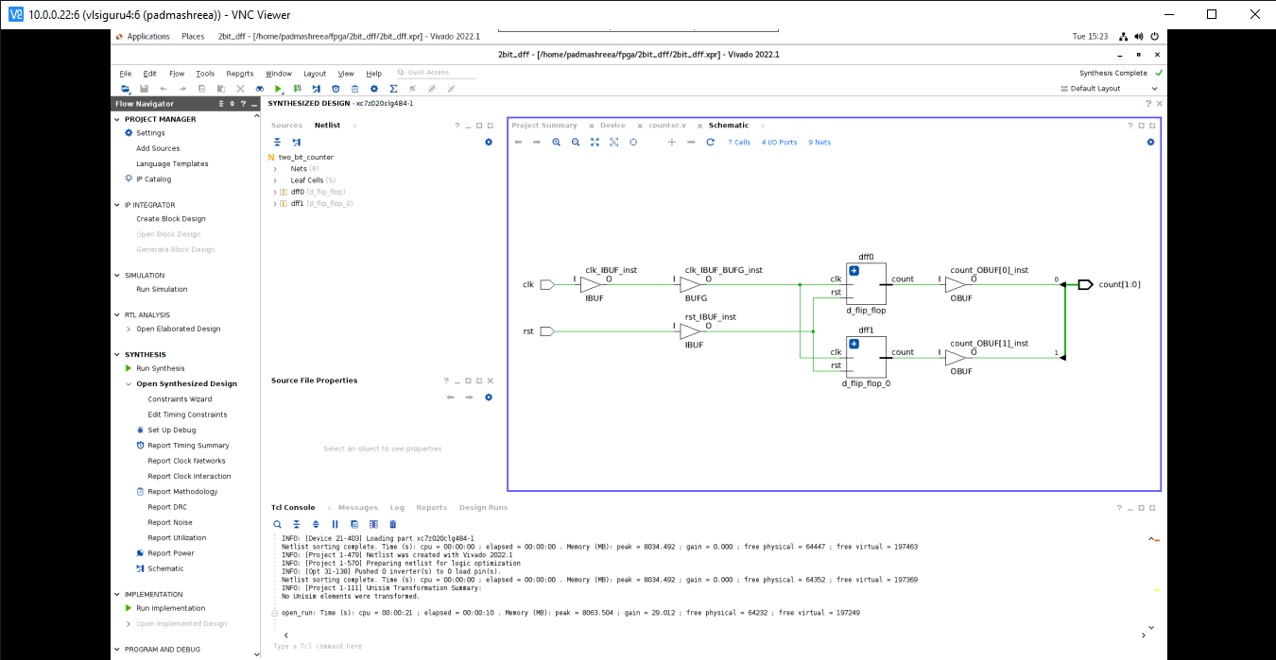

**Elaborated circuit:**

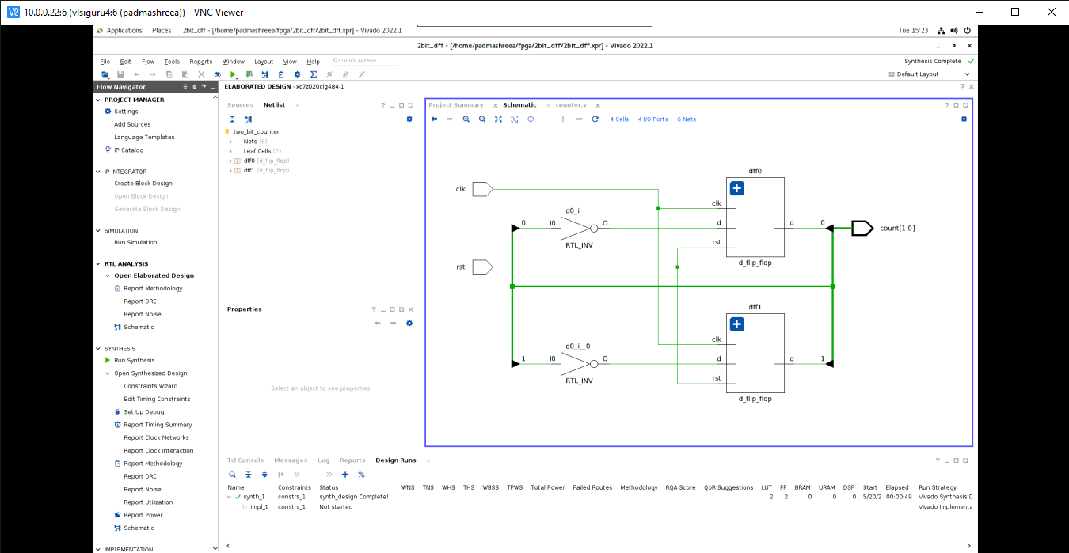

**Implement 3-bit multiplier using half adder**

**RTL/Verilog code:**

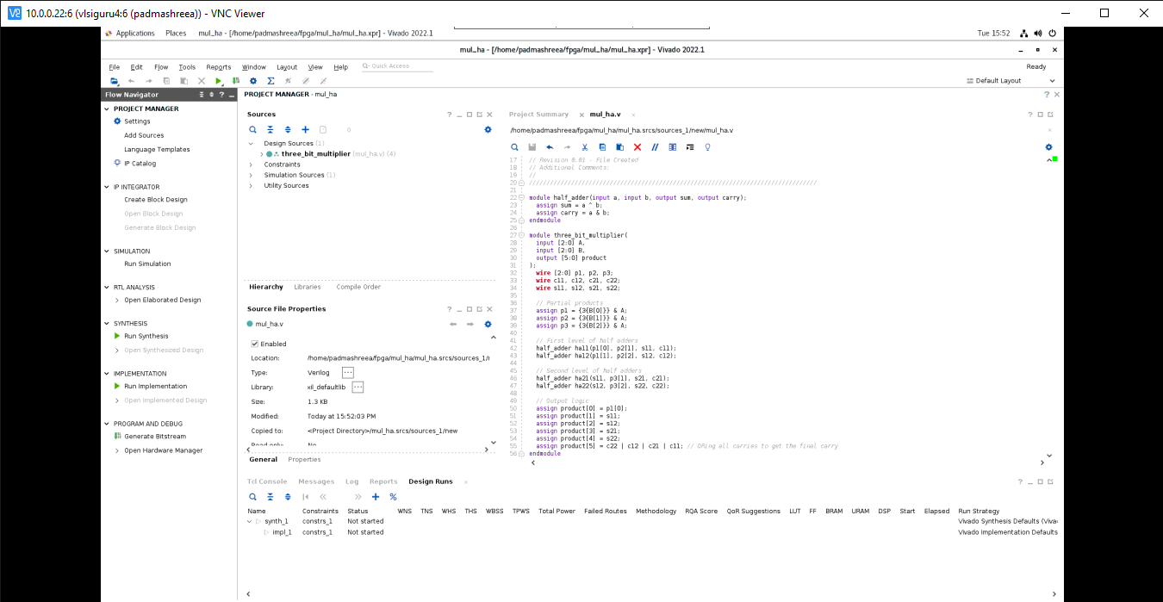

**Schematic diagram:**

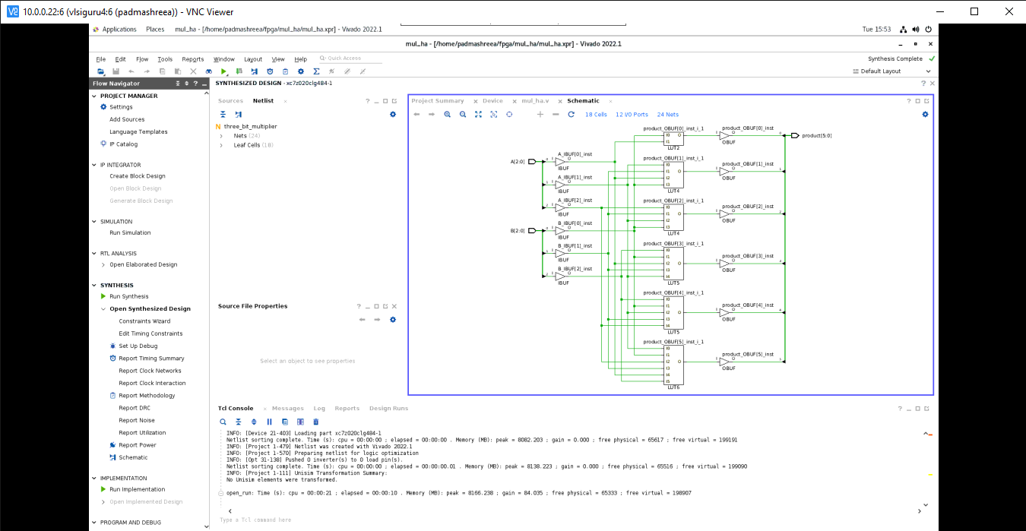

**Elaborated circuit diagram:**

